Native Americans Choice Board
Directions: Read the descriptions of the assignments below. Choose two activities to complete.

Choices (Choose one product out of two different categories):
1. Visual Spatial (thinking in terms of physical space; aware of own environment):
- Make a model of the settlement on Roanoke Island. Be sure to show what the settlement was like, where the Native Americans lived, and what became of the colonists. Do some research in at least one book and one internet site in order to learn what the land was like, what the settlement looked like, and what the Native American villages looked like. Make sure to cite your sources of information somewhere on your product. You may complete this individually, with a partner, or with a small group.
- Construct a model of an Iroquois council house. Be sure to show what the inside and outside looked like. Include the people that would have been present at the meeting. Be able to explain the parts of your model and the role of the people. Use the Internet and resource books to do your research. Be sure to cite your sources somewhere on your product. You may complete this individually, with a partner, or with a small group.

2. Interpersonal (understanding and interacting with others):
- Work with a partner. Pretend that you are planning a trip to establish a colony in the new world. You need to make an appeal to the queen for money, supplies, and ships. Draw up a plan for what supplies you will need, who you will take, where you will settle, what route you will take, what the settlement will be like, who you will encounter, and what dangers you will face. Do research in at least one book and one Internet site to find out about the plan for the Roanoke Island settlement. Make sure to cite your sources of information. Act out your appeal to the queen for the class.
- With a group of 1-3 friends, act out a meeting of the Iroquois Confederacy or the U.S. Congress. Choose an issue to meet about. Make sure that your meeting follows the correct procedure it should. Make sure that a decision is made in the manner in which it should be made. Formulate a new law from this decision in the correct way. Use the Internet and resource books for information. Be sure to cite your sources of information somewhere on your product.
- Use what you have learned about the Native Americans during this unit to create a new group of Native Americans. Give your group a name and choose a location in the United States. Decide how your group was able to protect themselves, what they ate, how they got food, what types of houses they lived in, one ceremony they had, what clothing they wore, five laws they had, what type of government they had, and what their family life was like (roles of men, women, and children). Think about how the climate and geography would affect their ways of life. Draw a map or make a model of the village on a piece of butcher paper. Choose one of the following ways to share information with the class: oral report, storybook, song, or skit. Be prepared to defend the decisions you make. You may work with 1-2 friends on this assignment.

3. Linguistic (using words effectively):
- Pretend that you are one of the Roanoke colonists. Write a diary of your life as that colonist. Be sure to include background information, tales of your life in England, tales of the voyage, tales of the settlement on the island, and tales of your fate based on one of the theories. Do some research in at least one book and one Internet site to see what life was like during the time in order to make your diary more authentic. Make sure to cite your sources of information somewhere on your product. You may choose to type your diary, but it is not a requirement. You may complete this individually, with a partner, or with a small group.
- Now that you have learned about various types of Native American myths, write and illustrate one of your own. You may choose to write a myth about how someone got their name on the day they were born. You may choose to write a myth, involving animals or people interacting with the environment. Lastly, you could choose to write a rebus story in which Native American symbols take the place of some of the words in your myth (rebus story-see Native Americans page 147). First complete the attached diagram in order to brainstorm ideas. Then, write a rough draft of your story. After editing it, type your story using Word or Publisher. Print it out and illustrate it. Then, share it with the class. You may complete this individually, with a partner, or with a small group.
- Using resource books and the Internet, research one famous Native American woman found on page 19 in the Native Americans book. Find out what tribe she is a member of, where the tribe is located, the top five most important facts about her past in order of importance, and what she has done to further the cause of women and/or Native Americans. Prepare a book or a poster about her and be sure to include illustrations. Be sure to cite your sources of information. You may complete this individually or with a partner.
- Using resource books and the Internet, research one Native American group. Find out the area of the country they live(d) in, the climate of that area, the geographical features of that area, how they protected themselves, food they ate and how they got it, the types of houses they lived in, ceremonies they had, clothing they wore, their laws/government, and gender roles. Prepare a Photo Story, using illustrations that you create yourself. Be sure to cite your sources of information. You may work on this individually or with a partner.

4. Intrapersonal (understanding one’s own interests and goals):
- Imagine that you were forming your own country and had to write a constitution. Pick a name for your country and outline the purpose of your government, the members, their qualifications, their duties, the process used to choose them, the procedures of government, and the laws. Think about what ideals are most important to you as you work. Borrow at least one idea from both the Iroquois Confederacy Constitution and from the U.S. Constitution. This is an individual assignment.

Extension: If you finish with the two choice activities, have your teacher check your work. Then you may choose another project to complete.

Helpful Technology:
http://www.foxnews.com/scitech/2012/05/07/new-clue-to-mystery-lost-roanoke-colony/
http://www.kidinfo.com/american_history/colonization_colonial_life.html
http://www.nationalcenter.org/ColonyofRoanoke.html
http://en.wikipedia.org/wiki/Roanoke_Colony
http://ncpedia.org/history/early/native-settlement
http://www.bigorrin.org/iroquois_kids.htm
http://www.kidinfo.com/american_history/colonization_colonial_life.html
http://en.wikipedia.org/wiki/List_of_Native_American_women_of_the_United_States
http://www.native-languages.org/kids.htm
http://nativeamericans.mrdonn.org/tribes.html
http://www.kidinfo.com/american_history/native_americans.html

Native American Myths Word Web

Directions:
Topic Choice
Main Characters

Setting

Title of story

Natural Phenomenon

Problem
Solution

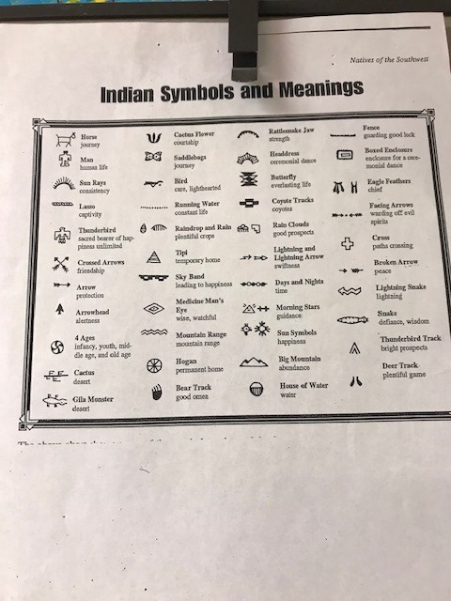

Native American Myth Rebus Symbols

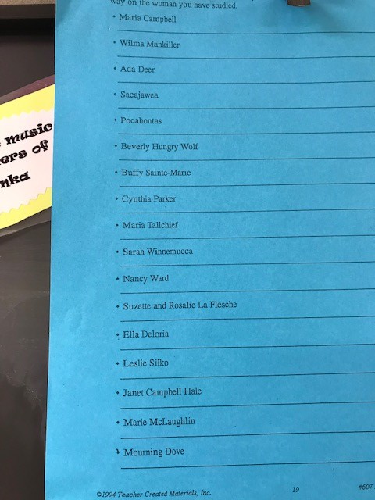

Famous Native American Women

